The title of the paper should be concise and informative. It should be written clearly and concisely describing the contents of the research (Times new roman 14, Bold)

Malik B. ¹, Pirzadah, T. B.², Abdin, M. Z.¹ and Rehman, R. U.¹ (Times new roman 12, Bold)

¹Department of Bioresources, University of Kashmir, Hazratbal, Srinagar, J&K, India; ²Centre for Biotechnology, Hamdard University, New Delhi, India. (Times new roman 10)

Malik B., Pirzadah, T. B., Abdin, M. Z. and Rehman, R. U. (YEAR). Somatic embryogenesis and embryoids formation in chicory (Cichorium intybus L.) International Journal of Agricultural Technology X(X): XX-XX. (Times new roman 10)

Abstract Abstract must be stated the result. It is no needed to write the objective, methods, snd experimental design. The abstract should be written as a single paragraph. Abstract must be written not more than 300 words. (Times new roman 10)
Template

Keywords: The keywords should be avoiding general and plural terms and multiple concepts. Do not use words or terms in the title as keywords. These keywords will be used for indexing purposes. Keywords should not more than 5 words or phrases in alphabetical order. (Times new roman 10)

Introduction (Times new roman 12, Bold)

The background information, statement of problem or research finding, avoiding a detailed literature survey or a summary of the results. Explain how you identiffy the problem with references cited. Introduction must be written approximately between 750 to 1000 words. (Times new roman 12)
State the objectives of the work.

Materials and methods (Times new roman 12, Bold)

It should be stated time and place of research. The experimental design, treatments, replication, and statistical analyis. Materials and methods must be stated for each experimental paets and be written approximately 500 to 800 words. (Times new roman 12)
Results (Times new roman 12, Bold)

Subtitle (if so) (Times new roman 12, Bold, Italic)

(Text in Times New Roman 12 Font, single spacing). Result must be explained cleary with statistical analysis. Writing the output of the experiments, model or computation in each part. This part is no needed to express your opinion or interpretation including stated Tables and/or Figures. (Times new roman 12)

Tables and Figures: All tables and Figures are to be numbered using Arabic numerals. Tables and figures should always be cited in text in consecutive numerical order. For each table or figure, please supply a caption (title) explaining the components of the table or figures. Footnotes to tables and figures should be indicated by superscript lower-case letters.

Template
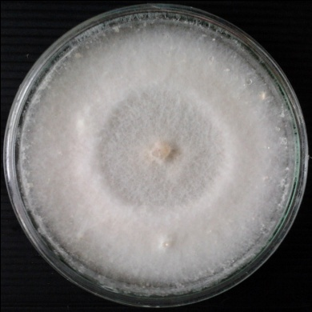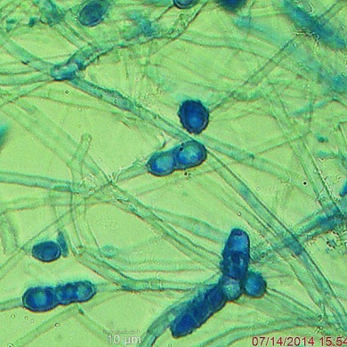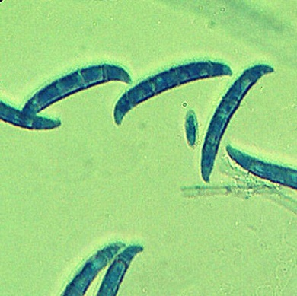
C
B
A
Figure 1. Xxxxxxxxxxxxxxxxxxxxxxxxxxxxx (Times new roman 12)

Table 1. Xxxxxxxxxxxxxxxxxxxx (Times new roman 12)
Crude extracts  (Times new roman 10) | Concentration (ppm) | Number of spores ^{/1}(10⁶) | inhibition(%)^{/2,3} | ED₅₀
 | Template

¹/Xxxxxxxxxxxxxxxxxxxxxxxxxxxxxxxxxxxxxxxxxxxxxxxxxxxxxxxxxxxxxxxxxxxxxxxx
²/ Xxxxxxxxxxxxxxxxxxxxxxxxxxxxxxxxxxxxxxxxxxxxxxxxxxxxxxxxxxxxxxxxxxxxxxx
³/ Xxxxxxxxxxxxxxxxxxxxxxxxxxxxxxxxxxxxxxxxxxxxxxxxxxxxxxxxxxxxxxxxxxxxxxx

Table 2. Xxxxxxxxxxxxxxxxxxxxxxxxxxxxxxxx
Antagonist fungi | Colletotrichum coffeanum
Antagonist fungi | Colony(cm) | % inhibition of colony
Control | 9.00^{a1/} | -
Nigrospora spp. | 5.66^{d} | 37.02ª
Fusarium chamydosporum | 5.82^{d} | 35.28ª
Phoma exigua | 6.68^{b} | 25.75^{c}
Phialophora spp. | 6.25^{c} | 30.55^{b}
CV% | 1.77 | 4.57

1/: Xxxxxxxxxxxxxxxxxxxxxxxxxxxxxxxxxxxxxxxxxxxxxxxxxxxxxxxxxxxxxxxxxxxxxxx

Discussion (with cited references) (Times new roman 12, Bold)

The discussion part, it would be compared your result with the other research works with reference cited. Compare your results that as same as others or contradict to the other with references cited. Recommendation, suggestion, comment, and summary must be included in the last paragraph. (Times new roman 12)

Acknowledgements (Times new roman 12, Bold)
Template

Acknowledgments of people, grants, funds, etc. should be placed in this section. The names of funding organizations should be written in full. (Times new roman 10)

Conflicts of interest (Times new roman 12, Bold)

The authors declare no conflict of interest. (Times new roman 10)

(Conflicts of interest must be declared by the authors in the International Journal of Agricultural Technology (IJAT). Authors should disclose any potential conflicts of interest which could influence the published research article including financial, personal and institutional affiliations to maintain the integrity of review and decision-making processes. In the manuscript, authors should explicitly state any conflicts of interest or declare "The authors declare no conflict of interest" if applicable.)

References (Times new roman 12, Bold)

The referenced documents (including citations in tables and legends) should be listed individually at the end of the manuscript and sorted alphabetically. All references must be in English, if reference document is in other languages, the author must translate them into English. Sample references as bellow: (Times new roman 10)

Journal article
Abdin, M. Z. and Ilah, A. (2007). Plant regeneration through somatic embryogenesis from stem and petiole explant of chicory (Cichorium intybus L). Indian Journal of Biotechnology, 6:250-255.

Textbook

Vasseur, J., Dubois, J., Hilbert, J. L. and Couillerot, J. P. (1995). Somatic embryogenesis in chicory (Cichorium species). In: Bajaj YS ed. Biotechnology in agriculture and forestry, Berlin, Springer Verlag, pp. 125-137.

International Conference
Yeung, E. C., Aitken, J., Biondi, S. and Thorpe, T. A. (1981). Somatic embryogenesis from Coffea callus and protoplast. VIth International Conference of Plant Tissue and Cell Culture, Minneapolis, MN, 137 p.

Thesis

Malapit, G (2001). Low Temperature PECVD Diamond and DLC Thin Films. (Master Thesis). University of the Philipines Diliman, Philippines.

Online

Clay, R. (2008). Science vs ideology: Psychologists fight back about the misuse
of research. Monitor on Phychology 39(6). Retrieved from http://www.apa.org/monitor/

NOTE: Please follow up our author guidelines.

Templte

Corresponding Author: Rehman, R. U.; Email: rreiazbiores@gmail.com (Time new roman 10)

